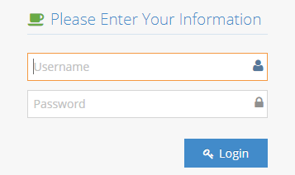
STEP 01: Visit ITRC e-Clerk System using www.itrc.sjp.ac.lk/e-clerk

Step 02: Login to the Systems using given username and password

Step 03: Select “Reserve a Lab” Icon

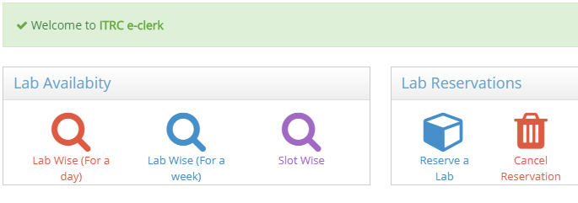

Step 04: Fill the form and click on Submit Button

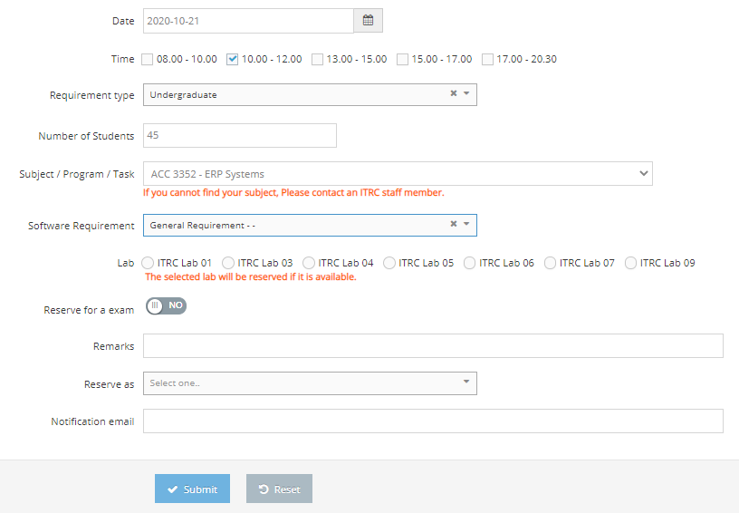

Note: You will Receive Confirmation email after the request is approved by the coordinator ITRC.

Three types of Search Facility
- Lab wise (For a Week)
- Lab wise (For a Day)
- Slot wise

Step 01: Select relevant search option

Step 02: Fill the relevant fields and click on Search Button

Lab wise (For a Week) | 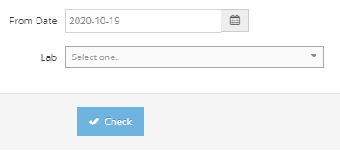 | - Select the start date of the required week  - Select the required Lab  - Click on Check
Lab wise (For a Day) | 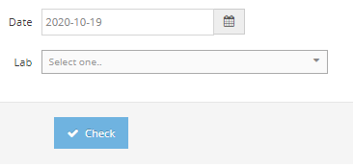 | - Select the required date  - Select the required Lab  - Click on Check
Slot wise | 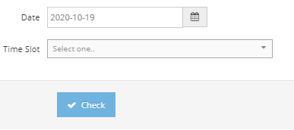 | - Select the required date  - Select the required Lab  - Click on Check

